**Experiment No 1.**

**Aim:** To implement DDA algorithms for drawing a line segment between two given end points.

**Objective:** Draw the line using (vector) generation algorithms which determine the pixels that should be turned ON are called as digital differential analyzer (DDA).It is one of the techniques for obtaining a rasterized straight line. This algorithm can be used to draw the line in all the quadrants.

**Theory:**

DDA algorithm is an incremental scan conversion method. Here we perform calculations at each step using the results from the preceding step. The characteristic of the DDA algorithm is to take unit steps along one coordinate and compute the corresponding values along the other coordinate. Digital Differential Analyzer (DDA) algorithm is the simple line generation algorithm which is explained step by step here.

**Algorithm:**

Input the two endpoints of the line segment, (x1,y1) and (x2,y2).

Calculate the difference between the x-coordinates and y-coordinates of the endpoints as dx and dy respectively.

Calculate the slope of the line as m = dy/dx.

Set the initial point of the line as (x1,y1).

Loop through the x-coordinates of the line, incrementing by one each time, and calculate the corresponding y-coordinate using the equation y = y1 + m(x – x1).

Plot the pixel at the calculated (x,y) coordinate.

Repeat steps 5 and 6 until the endpoint (x2,y2) is reached.

**Program:**

#include<graphics.h>

#include<math.h>

#include<conio.h>

void main()

{

int x0,y0,x1,y1,i=0;

float delx,dely,len,x,y;

int gr=DETECT,gm;

initgraph(&gr,&gm,"C:\\TURBOC3\\BGI");

printf("\n****** DDA Line Drawing Algorithm ***********");

printf("\n Please enter the starting coordinate of x, y = ");

scanf("%d %d",&x0,&y0);

printf("\n Enter the final coordinate of x, y = ");

scanf("%d %d",&x1,&y1);

dely=abs(y1-y0);

delx=abs(x1-x0);

if(delx<dely)

{

len = dely;

}

else

{

len=delx;

}

delx=(x1-x0)/len;

dely=(y1-y0)/len;

x=x0+0.5;

y=y0+0.5;

do{

putpixel(x,y,3);

x=x+delx;

y=y+dely;

i++;

delay(30);

}while(i<=len);

getch();

closegraph();

}

**Output:**

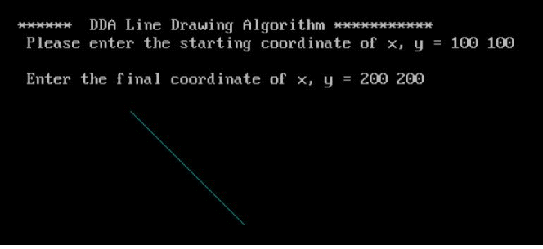

**Conclusion:** Comment on -

1. Pixel
2. Equation for line
3. Need of line drawing algorithm
4. Slow or fast

**Pixel:** In the context of the DDA algorithm, a pixel refers to the smallest unit of a digital image that can be displayed on a screen. The DDA algorithm is used for efficient rendering of lines on a digital display, which involves determining which pixels to activate to represent the desired line.

**Equation for line:** The DDA algorithm uses the equation of a line to calculate the coordinates of the points on the line. The equation used is typically the slope-intercept form of a line, which is y = mx + c, where 'm' is the slope of the line and 'c' is the y-intercept.

**Need for line drawing algorithm:** Line drawing algorithms like DDA are necessary for efficient and accurate rendering of lines on digital displays, such as computer monitors or screens. Without such algorithms, it would be challenging to accurately represent lines and shapes in computer graphics and various applications that involve graphical representations.

**Slow or fast:** The DDA algorithm is relatively simple and straightforward, making it easy to implement. However, it is not the most efficient algorithm for drawing lines, especially when dealing with lines that are steep or near-horizontal. DDA can be considered relatively slow compared to some of the more advanced line drawing algorithms like Bresenham's line algorithm, which provides better performance by using integer increments and avoiding floating-point arithmetic.

**Experiment No. 2**

**Aim:** To implement Bresenham’s algorithms for drawing a line segment between two given end points.

**Objective:**

Draw a line using Bresenham's line algorithm that determines the points of an n-dimensional raster that should be selected to form a close approximation to a straight line between two points

**Theory:**

In Bresenham’s line algorithm pixel positions along the line path are obtained by determining the pixels i.e. nearer the line path at each step.

Algorithm –

**Step1:** Start Algorithm

**Step2:** Declare variable x1,x2,y1,y2,d,i1,i2,dx,dy

**Step3:** Enter value of x1,y1,x2,y2  
                Where x1,y1are coordinates of starting point  
                And x2,y2 are coordinates of Ending point

**Step4:** Calculate dx = x2-x1  
                Calculate dy = y2-y1  
                Calculate i1=2*dy  
                Calculate i2=2*(dy-dx)  
                Calculate d=i1-dx

**Step5:** Consider (x, y) as starting point and xend as maximum possible value of x.  
                If dx < 0  
                        Then x = x2  
                        y = y2  
                          xend = x1  
                If dx > 0  
                    Then x = x1  
                y = y1  
                        xend = x2

**Step6:** Generate point at (x,y)coordinates.

**Step7:** Check if whole line is generated.  
                If x > = xend  
                Stop.

**Step8:** Calculate co-ordinates of the next pixel  
                If d < 0  
                    Then d = d + i1  
                If d ≥ 0  
          Then d = d + i2  
                Increment y = y + 1

**Step9:** Increment x = x + 1

**Step10:** Draw a point of latest (x, y) coordinates

**Step11:** Go to step 7

**Step12:** End of Algorithm

**Program –**

#include<graphics.h>

#include<stdio.h>

void main()

{

int x,y,x1,y1,delx,dely,m,grtr_d,smlr_d,d;

int gm,gd=DETECT;

initgraph(&gd,&gm,"C:\\TC\\BGI");

printf("******* BRESENHAM'S LINE DRAWING ALGORITHM *****\n\n");

printf("enter initial coordinate = ");

scanf("%d %d",&x,&y);

printf("enter final coordinate = ");

scanf("%d %d",&x1,&y1);

delx=x1-x;

dely=y1-y;

grtr_d=2*dely-2*delx;&nbsp; &nbsp;// when d > 0

smlr_d=2*dely;&nbsp; &nbsp; &nbsp; &nbsp; &nbsp; // when d< 0

d=(2*dely)-delx;

do{

putpixel(x,y,1);

if(d<0) {

d=smlr_d+d;

}

else

{

d=grtr_d+d;

y=y+1;

}

x=x+1;

}while(x<x1);

getch();

}

**OUTPUT:**

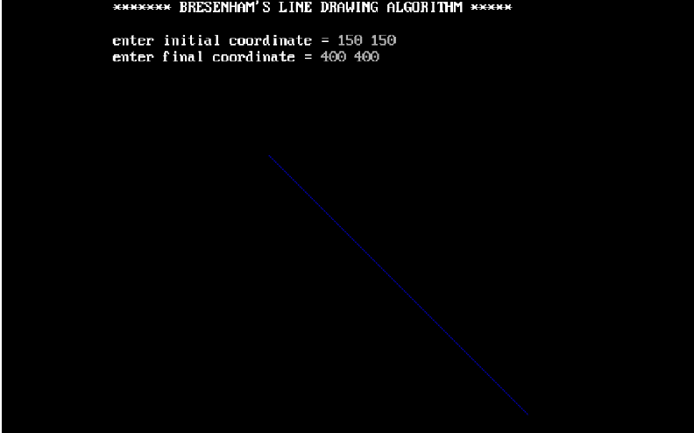

**Conclusion:** Comment on -

1. Pixel
2. Equation for line
3. Need of line drawing algorithm
4. Slow or fast

**Pixel:** In the context of Bresenham's line drawing algorithm, a pixel refers to the smallest unit of display in a digital raster display. The algorithm is primarily used for drawing lines on a pixel grid. Bresenham's algorithm efficiently determines which pixels to illuminate in order to represent a straight line between two points on a discrete two-dimensional grid.

**Equation for line**: Bresenham's algorithm is specifically designed for drawing lines on a computer screen or any two-dimensional grid system. Unlike the traditional line drawing equation (y = mx + c) which involves floating-point arithmetic and rounding, Bresenham's algorithm uses integer arithmetic and bit manipulation to draw lines. The algorithm works based on the decision between two candidate pixels at each step, avoiding the need for floating-point calculations.

**Need for line drawing algorithm:** Drawing a line between two points is a fundamental operation in computer graphics and image processing. Bresenham's algorithm is particularly useful for drawing lines efficiently on digital displays, especially in older hardware where floating-point operations were computationally expensive. It is essential for the efficient and fast rendering of lines on digital screens, contributing significantly to the development of computer graphics.

**Slow or fast:** Bresenham's algorithm is considered fast and efficient compared to other algorithms for drawing lines. It optimizes the process of determining which pixels to illuminate to create a straight line between two points. Since it uses integer arithmetic and bitwise operations instead of floating-point arithmetic, it is more suitable for hardware implementations and significantly speeds up the line drawing process. However, it's important to note that the efficiency of the algorithm can be impacted by the hardware's capabilities and the complexity of the line being drawn

**Experiment No. 3**

**Aim**: To implement midpoint circle algorithm.

**Objective:**

Draw a circle using mid-point circle drawing algorithm by determining the points needed for

rasterizing a circle. The mid-point algorithm to calculate all the perimeter points of the circle

in the first octant and then print them along with their mirror points in the other octants.

**Theory:**

The shape of the circle is similar in each quadrant. We can generate the points in one section

and the points in other sections can be obtained by considering the symmetry about x-axis

and y-axis.

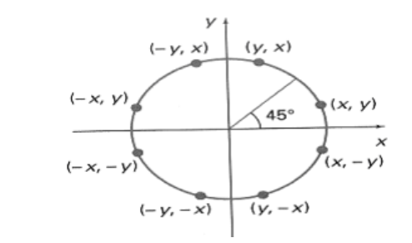

The equation of circle with center at origin is x 2 + y 2 = r 2

Let the circle function is f circle (x, y) -

• is &lt; 0, if (x, y) is inside circle boundary,

• is = 0, if (x, y) is on circle boundary,

• is &gt; 0, if (x, y) is outside circle boundary.

Consider the pixel at (xk, yk) is plotted,

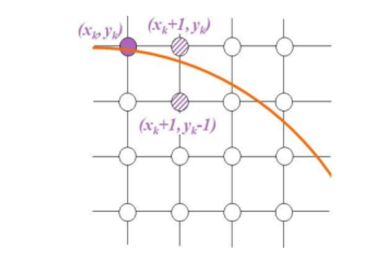

Now the next pixel along the circumference of the circle will be either (xk + 1, yk) or (xk + 1,

yk – 1) whichever is closer the circle boundary.

Let the decision parameter pk is equal to the circle function evaluate at the mid-point between

two pixels.

If pk &lt; 0, the midpoint is inside the circle and the pixel at yk is closer to the circle boundary.

Otherwise, the midpoint is outside or on the circle boundary and the pixel at yk – 1 is closer

to the circle boundary.

Algorithm –

**Step1:** Put x =0, y =r in equation 2  
            We have p=1-r

**Step2:** Repeat steps while x ≤ y  
            Plot (x, y)  
            If (p<0)  
Then set p = p + 2x + 3  
Else  
            p = p + 2(x-y)+5  
            y =y - 1 (end if)  
            x =x+1 (end loop)

**Step3:** End

Program –

#include<graphics.h>

#include<conio.h>

#include<stdio.h>

void main()

{

int x,y,x_mid,y_mid,radius,dp;

int g_mode,g_driver=DETECT;

clrscr();

initgraph(&g_driver,&g_mode,"C:\\TURBOC3\\BGI");

printf("*********** MID POINT Circle drawing algorithm ********\n\n");

printf("\nenter the coordinates= ");

scanf("%d %d",&x_mid,&y_mid);

printf("\n now enter the radius =");

scanf("%d",&radius);

x=0;

y=radius;

dp=1-radius;

do

{

putpixel(x_mid+x,y_mid+y,YELLOW);

putpixel(x_mid+y,y_mid+x,YELLOW);

putpixel(x_mid-y,y_mid+x,YELLOW);

putpixel(x_mid-x,y_mid+y,YELLOW);

putpixel(x_mid-x,y_mid-y,YELLOW);

putpixel(x_mid-y,y_mid-x,YELLOW);

putpixel(x_mid+y,y_mid-x,YELLOW);

putpixel(x_mid+x,y_mid-y,YELLOW);

if(dp<0) {

dp+=(2*x)+1;

}

else{

y=y-1;

dp+=(2*x)-(2*y)+1;

}

x=x+1;

}while(y>x);

getch();

}

**output –**

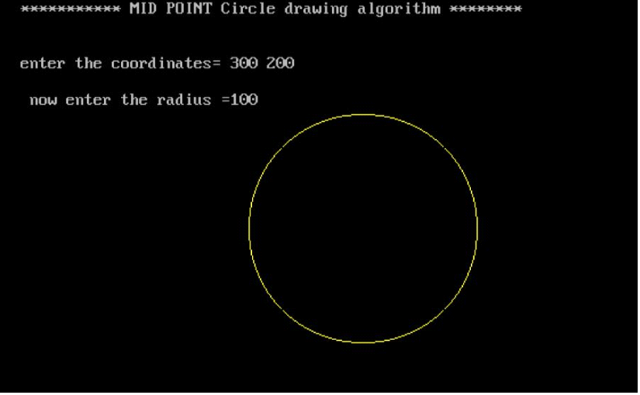

**Conclusion: Comment on**

**1. Fast or slow**

**2. Draw one arc only and repeat the process in 8 quadrants**

**3. Difference with line drawing method**

**Fast or slow:** The Midpoint Circle Algorithm is relatively fast compared to other algorithms for drawing circles, such as the Bresenham's circle drawing algorithm. It involves only integer arithmetic operations, making it efficient for implementation on devices with limited computational capabilities. However, it's worth noting that the execution speed may still depend on the hardware and implementation specifics.

**Draw one arc only and repeat the process in 8 quadrants:** The Midpoint Circle Algorithm indeed draws one-eighth of the circle (either the first or the last 45 degrees, depending on the implementation) and then replicates this in the other octants by exploiting the symmetry of the circle. This approach significantly reduces the computational effort needed to draw a complete circle.

**Difference with line drawing method:** The Midpoint Circle Algorithm differs from line drawing algorithms, such as Bresenham's line algorithm, primarily in the way it calculates the points on the circumference of the circle. While line drawing algorithms determine which pixels to turn on or off along a straight line, the Midpoint Circle Algorithm focuses on determining the points along the circular path using a midpoint-based approach, considering the symmetry and the incremental computation of the coordinates.

**Experiment No. 4**

**Aim**-To implement midpoint Ellipse algorithm

**Objective:**

Draw the ellipse using Mid-point Ellipse algorithm in computer graphics. Midpoint ellipse

algorithm plots (finds) points of an ellipse on the first quadrant by dividing the quadrant into

two regions.

**Theory:**

Midpoint ellipse algorithm uses four way symmetry of the ellipse to generate it. Figure shows

the 4-way symmetry of the ellipse.

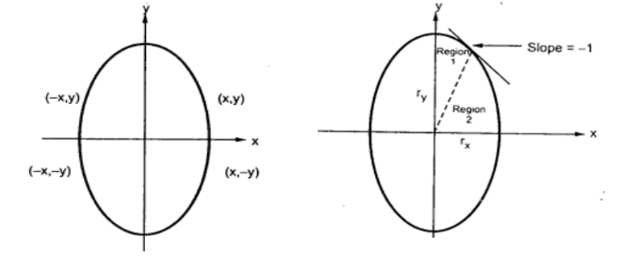

Here the quadrant of the ellipse is divided into two regions as shown in the fig. Fig. shows the

division of first quadrant according to the slope of an ellipse with rx &lt; ry. As ellipse is drawn

from 90 0 to 0 0 , x moves in positive direction and y moves in negative direction and ellipse

passes through two regions 1 and 2.

The equation of ellipse with center at (xc, yc) is given as -

[(x – xc) / rx] 2 + [(y – yc) / ry] 2 = 1

Therefore, the equation of ellipse with center at origin is given as -

[x / rx] 2 + [y / ry] 2 = 1

i.e. x 2 ry 2 + y 2 rx 2 = rx 2 ry 2

Let, f ellipse (x, y) = x2 ry2 + y2 rx2 - rx2 ry2

**Algorithm:**

**Program**

#include<stdio.h>

#include<conio.h>

#include<graphics.h>

void pixel(int x,int y,int xc,int yc)

{

putpixel(x+xc,y+yc,BLUE);

putpixel(x+xc,-y+yc,BLUE);

putpixel(-x+xc,y+yc,BLUE);

putpixel(-x+xc,-y+yc,BLUE);

putpixel(y+xc,x+yc,BLUE);

putpixel(y+xc,-x+yc,BLUE);

putpixel(-y+xc,x+yc,BLUE);

putpixel(-y+xc,-x+yc,BLUE);

}

main()

{

int gd=DETECT,gm=0,r,xc,yc,x,y;

float p;

//detectgraph(&gd,&gm);

initgraph(&gd,&gm," ");

printf(“\n ********* MID POINT ELLIPSE ALGORITHM ********* ”)

printf("\n Enter the radius of the circle:");

scanf("%d",&r);

printf("\n Enter the center of the circle:");

scanf("%d %d",&xc,&yc);

y=r;

x=0;

p=(5/4)-r;

while(x<y)

{

if(p<0)

{

x=x+1;

y=y;

p=p+2*x+3;

}

else

{

x=x+1;

y=y-1;

p=p+2*x-2*y+5;

}

pixel(x,y,xc,yc);

}

getch();

closegraph();

}

**Output:**

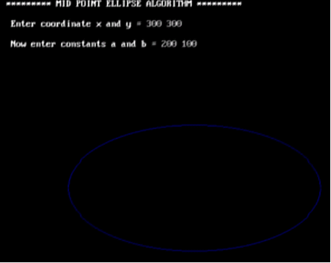

**Conclusion**: Comment on

1. Slow or fast

2. Difference with circle

3. Importance of object

**Speed:** The midpoint ellipse algorithm is relatively faster compared to other algorithms for drawing ellipses. It efficiently utilizes incremental calculations, which helps in reducing computational overhead, making it suitable for real-time graphics applications.

**Differences with circles:** The midpoint ellipse algorithm differs from the midpoint circle algorithm in terms of the decision parameters and the way points are plotted. While both algorithms utilize the concept of symmetry and incremental calculations, the parameters and equations for ellipses are different from those for circles due to the variation in the geometry of these two shapes.

**Importance of the object:** The significance of the object being drawn lies in the context of the application. Ellipses are fundamental geometric shapes used in various computer graphics applications, including drawing, modeling, and image processing. They are essential for representing various objects such as orbits, paths, shapes, and boundaries in computer graphics. The midpoint ellipse algorithm provides an efficient and accurate way to render ellipses, which is crucial for generating complex graphics and accurately representing objects in a wide range of applications.

**Experiment No. 5**

**Aim:**  To implement Area Filling Algorithm: Boundary Fill, Flood Fill.

**Objective:**

Polygon is an ordered list of vertices as shown in the following figure. For filling polygons with particular colors, we need to determine the pixels falling on the border of the polygon and those which fall inside the polygon. Objective is to demonstrate the procedure for filling polygons using different techniques.

**Theory:**

**1) Boundary Fill algorithm –**

Start at a point inside a region and paint the interior outward toward the boundary. If the boundary is specified in a single color, the fill algorithm processed outward pixel by pixel until the boundary color is encountered. A boundary-fill procedure accepts as input the coordinate of the interior point (x, y), a fill color, and a boundary color.

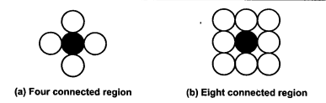

**Procedure:**

boundary_fill (x, y, f_color, b_color)

{

if (getpixel (x, y) != b_colour && getpixel (x, y) != f_colour)

{

putpixel (x, y, f_colour)

boundary_fill (x + 1, y, f_colour, b_colour);

boundary_fill (x, y + 1, f_colour, b_colour);

boundary_fill (x - 1, y, f_colour, b_colour);

boundary_fill (x, y - 1, f_colour, b_colour);

}

}

**Program:**

#include<stdio.h>

#include<conio.h>

#include<graphics.h>

#include<doc.h>

void boundary_fill(int x, int y, int fcolor, int bcolor)

{

if ((getpixel(x, y) != bcolor) && (getpixel(x, y) != fcolor))

{

delay(10);

putpixel(x, y, fcolor);

boundary_fill(x + 1, y, fcolor, bcolor); boundary_fill(x , y+1, fcolor, bcolor); boundary_fill(x+1, y + 1, fcolor, bcolor); boundary_fill(x-1, y - 1, fcolor, bcolor); boundary_fill(x-1, y, fcolor, bcolor); boundary_fill(x , y-1, fcolor, bcolor); boundary_fill(x-1, y + 1, fcolor, bcolor); boundary_fill(x+1, y - 1, fcolor, bcolor);

}

}

void main()

{

int x, y, fcolor, bcolor;

int gd=DETECT,gm;

initgraph(&gd, &gm, "C:\\TurboC3\\BGI"); printf("Enter the seed point (x,y) : "); scanf("%d%d", &x, &y);

printf("Enter boundary color : "); scanf("%d", &bcolor); printf("Enter new color : ");

scanf("%d", &fcolor); rectangle(50,50,100,100); boundary_fill(x,y,fcolor,bcolor); getch();

}

**Output:**

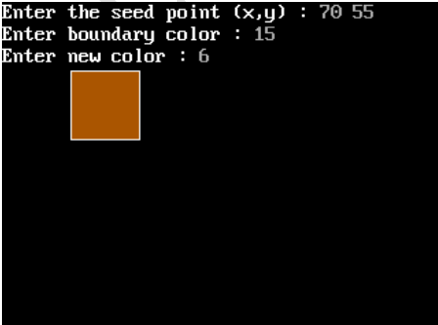

**2) Flood Fill algorithm –**

Sometimes we want to fill an area that is not defined within a single color boundary. We paint such areas by replacing a specified interior color instead of searching for a boundary color value. This approach is called a flood-fill algorithm.

1. We start from a specified interior pixel (x, y) and reassign all pixel values that are currently set to a given interior color with the desired fill color.

2. If the area has more than one interior color, we can first reassign pixel values so that all interior pixels have the same color.

3. Using either 4-connected or 8-connected approach, we then step through pixel positions until all interior pixels have been repainted.

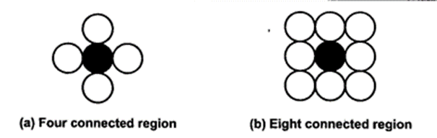

**Procedure -**

flood_fill (x, y, old_color, new_color)

{

if (getpixel (x, y) = old_colour)

{

putpixel (x, y, new_colour);

flood_fill (x + 1, y, old_colour, new_colour);

flood_fill (x - 1, y, old_colour, new_colour);

flood_fill (x, y + 1, old_colour, new_colour);

flood_fill (x, y - 1, old_colour, new_colour);

flood_fill (x + 1, y + 1, old_colour, new_colour);

flood_fill (x - 1, y - 1, old_colour, new_colour);

flood_fill (x + 1, y - 1, old_colour, new_colour);

flood_fill (x - 1, y + 1, old_colour, new_colour);

}

}

**Program:**

#include<stdio.h>

#include<graphics.h> #include<dos.h>

void flood(int,int,int,int); int main()

{

int gd,gm=DETECT; //detectgraph(&gd,&gm); initgraph(&gd,&gm," "); rectangle(50,50,100,100); flood(55,55,12,0); closegraph(); return 0;

} void flood(int x,int y, int fill_col, int old_col)

{

if(getpixel(x,y)==old_col)

{ delay(10); putpixel(x,y,fill_col); flood(x+1,y,fill_col,old_col); flood(x-1,y,fill_col,old_col); flood(x,y+1,fill_col,old_col); flood(x,y-1,fill_col,old_col); flood(x + 1, y + 1, fill_col, old_col); flood(x - 1, y - 1, fill_col, old_col); flood(x + 1, y - 1, fill_col, old_col); flood(x - 1, y + 1, fill_col, old_col);

}

}

**Output:**



**Conclusion:** Comment on

1. Importance of Flood fill
2. Limitation of methods
3. Usefulness of method

Flood fill is crucial in computer graphics for various tasks, such as coloring regions, filling areas with patterns or textures, and identifying bounded regions. It is instrumental in creating visually appealing and intuitive graphics in applications like drawing software, image editing tools, and video games.

Limitation of methods:

Despite its usefulness, flood fill algorithms can encounter limitations. One primary limitation is the possibility of stack overflow when dealing with large areas or when the recursion depth becomes too significant. Additionally, the traditional implementation of flood fill might not be suitable for handling complex shapes or irregular boundaries, as it may lead to leakage or bleeding of the fill outside the desired region

Usefulness of method:

The flood fill algorithm is incredibly useful in various applications, particularly in graphics and image processing. It enables the efficient filling of closed areas with desired colors, textures, or patterns. Moreover, it simplifies the implementation of numerous functionalities such as the paint bucket tool, region labeling, and boundary detection.

**Experiment No. 6**

**Aim:**  To implement 2D Transformations: Translation, Scaling, Rotation.

**Objective:**

To understand the concept of transformation, identify the process of transformation and application of these methods to different object and noting the difference between these transformations.

**Theory:**

**1) Translation –**

Translation is defined as moving the object from one position to another position along straight line path. We can move the objects based on translation distances along x and y axis. tx denotes translation distance along x-axis and ty denotes translation distance along y axis.

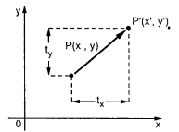

Consider (x,y) are old coordinates of a point. Then the new coordinates of that same point (x’,y’) can be obtained as follows:

**x’ = x + tx**

**y’ = y + ty**

We denote translation transformation as P. we express above equations in matrix form as:P’ = P + T , where

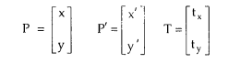

**Program:**

#include<stdio.h>

#include<conio.h>

#include<graphics.h>

#include<math.h>

void main()

{

int gd=DETECT,gm;

int x1,y1,x2,y2,tx,ty,x3,y3,x4,y4;

initgraph(&gd,&gm,"C:\\TurboC3\\BGI");

printf("Enter the starting point of line segment:");

scanf("%d %d",&x1,&y1);

printf("Enter the ending point of line segment:");

scanf("%d %d",&x2,&y2);

printf("Enter translation distances tx,ty:\n");

scanf("%d%d",&tx,&ty);

setcolor(5);

line(x1,y1,x2,y2);

outtextxy(x2+2,y2+2,"Original line");

x3=x1+tx;

y3=y1+ty;

x4=x2+tx;

y4=y2+ty;

setcolor(7);

line(x3,y3,x4,y4);

outtextxy(x4+2,y4+2,"Line after translation");

getch();

}

**Output –**

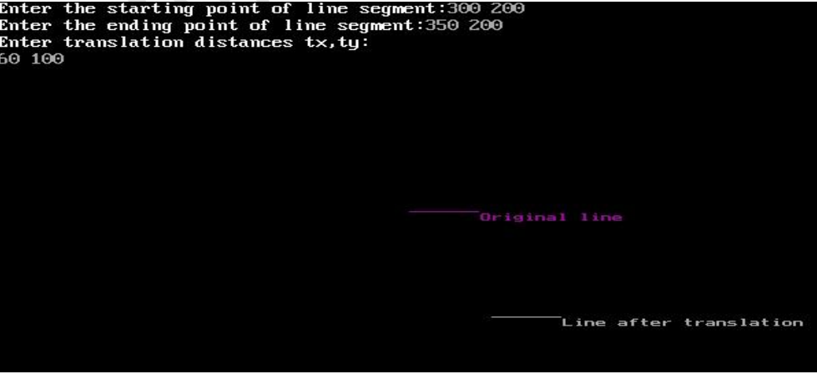

**2) Rotation –**

A rotation repositions all points in an object along a circular path in the plane centered at the

pivot point. We rotate an object by an angle theta. New coordinates after rotation depend on both x and y.

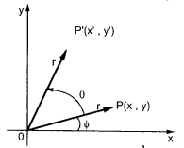



The above equations can be represented in the matrix form as given below

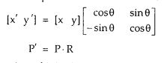

where R is the rotation matrix and it is given as



Program:

#include<stdio.h>

#include<conio.h>

#include<graphics.h>

#include<math.h>

void main()

{

int gd=DETECT,gm;

float x1,y1,x2,y2,x3,y3,x4,y4,a,t;

initgraph(&gd,&gm,"C:\\TurboC3\\BGI");

printf("Enter coordinates of starting point:\n");

scanf("%f%f",&x1,&y1);

printf("Enter coordinates of ending point\n");

scanf("%f%f",&x2,&y2);

printf("Enter angle for rotation\n");

scanf("%f",&a);

setcolor(5);

line(x1,y1,x2,y2);

outtextxy(x2+2,y2+2,"Original line");

t=a*(3.14/180);

x3=(x1*cos(t))-(y1*sin(t));

y3=(x1*sin(t))+(y1*cos(t));

x4=(x2*cos(t))-(y2*sin(t));

y4=(x2*sin(t))+(y2*cos(t));

setcolor(7);

line(x3,y3,x4,y4);

outtextxy(x3+2,y3+2,"Line after rotation");

getch();

**Output:**

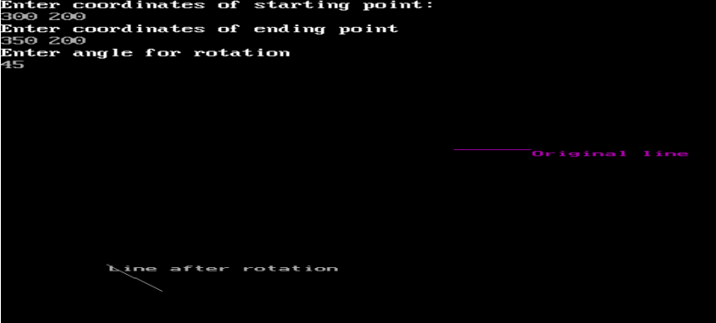

**3) Scaling -**

scaling refers to changing the size of the object either by increasing or decreasing. We will

increase or decrease the size of the object based on scaling factors along x and y-axis.

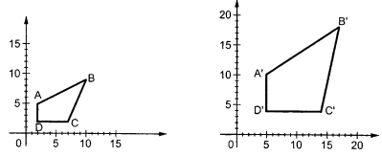

If (x, y) are old coordinates of object, then new coordinates of object after applying scaling

transformation are obtained as:

x’ = x * Sx

y’ = y * Sy

Sx and Sy are scaling factors along x-axis and y-axis. we express the above equations in matrix form as:

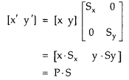

**Program:**

#include<stdio.h>

#include<conio.h>

#include<graphics.h>

#include<math.h>

void main()

{

int gd=DETECT,gm;

float x1,y1,x2,y2,sx,sy,x3,y3,x4,y4;

initgraph(&gd,&gm,"C:\\TurboC3\\BGI");

printf("Enter the starting point coordinates:");

scanf("%f %f",&x1,&y1);

printf("Enter the ending point coordinates:");

scanf("%f %f",&x2,&y2);

printf("Enter scaling factors sx,sy:\n");

scanf("%f%f",&sx,&sy);

setcolor(5);

line(x1,y1,x2,y2);

outtextxy(x2+2,y2+2,"Original line");

x3=x1*sx;

y3=y1*sy;

x4=x2*sx;

y4=y2*sy;

setcolor(7);

line(x3,y3,x4,y4);

outtextxy(x3+2,y3+2,"Line after scaling");

getch();

}

**Output –**

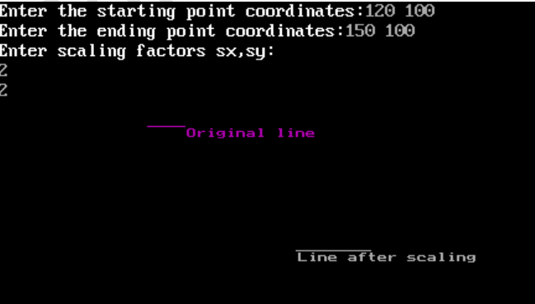

**Conclusion:**

Comment on :

1. Application of transformation
2. Difference noted between methods
3. Application on different object

Application of Transformation:

Transformations are fundamental concepts in computer graphics and geometry. They are used to manipulate objects in a coordinate system. The application of transformations allows for the repositioning, resizing, and reshaping of objects in a 2D or 3D space. These transformations are crucial in various fields, including computer animation, video game development, and image processing

Difference Noted between Translation, Rotation, Scaling:

Translation involves moving an object from one location to another without changing its orientation or size. It only affects the position of the object in the coordinate system. Rotation, on the other hand, involves turning an object around a fixed point, changing its orientation. It does not change the object's size or position, only its spatial orientation. Scaling refers to resizing an object either larger or smaller, without changing its shape. It affects the dimensions of the object but not its position or orientation.

Application of Translation, Rotation, Scaling on Different Objects:

Translation can be applied to various objects, such as moving a car along a road, shifting a text box on a computer screen, or relocating a character in a video game. Rotation finds application in scenarios like spinning a wheel, rotating a character in an animation, or tilting an object in a design. Scaling is used to change the size of objects, such as zooming in or out on an image, resizing a window on a computer screen, or adjusting the dimensions of a 3D model.

**Experiment No. 7**

**Aim:**  To implement Line Clipping Algorithm: Liang Barsky

**Objective:**

To understand the concept of Liang Barsky algorithm to efficiently determine the portion of a line segment that lies within a specified clipping window.  This method is particularly effective for lines predominantly inside or outside the window.

**Theory:**

This Algorithm was developed by Liang and Barsky. It is used for line clipping as it is more efficient because it uses more efficient parametric equations to clip the given line.

These parametric equations are given as:

x = x1 + tdx

y = y1 + tdy, 0 <= t <= 1

Where dx = x2 – x1 & dy = y2 – y1

**Algorithm**

1. Read 2 endpoints of line as p1 (x1, y1) & p2 (x2, y2).

2. Read 2 corners (left-top & right-bottom) of the clipping window as (xwmin, ywmin, xwmax, ywmax).

**3.** Calculate values of parameters pi and qi for i = 1, 2, 3, 4 such that

p1 = -dx, q1 = x1 – xwmin

p2 = dx, q2 = xwmax – x1

p3 = -dy, q3 = y1 – ywmin

p4 = dy, q4 = ywmax – y1

**4.** if pi = 0 then line is parallel to ith boundary

if qi < 0 then line is completely outside boundary so discard line

else, check whether line is horizontal or vertical and then check the line endpoints with the corresponding boundaries.

**5.** Initialize t1 & t2 as

t1 = 0 & t2 = 1

Ezoic

6. Calculate values for qi/pi for i = 1, 2, 3, 4.

7. Select values of qi/pi where pi < 0 and assign maximum out of them as t1.

**8.** Select values of qi/pi where pi > 0 and assign minimum out of them as t2.

**9.** if (t1 < t2)  
{  
xx1 = x1 + t1dx

xx2 = x1 + t2dx

yy1 = y1 + t1dy

yy2 = y1 + t2dy

line (xx1, yy1, xx2, yy2)  
}

**10.** Stop.

Program:

#include<stdio.h>

#include<graphics.h>

#include<math.h>

#include<dos.h>

int main()

{

int i,gd=DETECT,gm;

int x1,y1,x2,y2,xmin,xmax,ymin,ymax,xx1,xx2,yy1,yy2,dx,dy;

float t1,t2,p[4],q[4],temp;

x1=120;

y1=120;

x2=300;

y2=300;

xmin=100;

ymin=100;

xmax=250;

ymax=250;

initgraph(&gd,&gm," ");

rectangle(xmin,ymin,xmax,ymax);

dx=x2-x1;

dy=y2-y1;

p[0]=-dx;

p[1]=dx;

p[2]=-dy;

p[3]=dy;

q[0]=x1-xmin;

q[1]=xmax-x1;

q[2]=y1-ymin;

q[3]=ymax-y1;

for(i=0;i<4;i++)

{

if(p[i]==0)

{

printf("line is parallel to one of the clipping boundary");

if(q[i]>=0)

{

if(i<2)

{

if(y1<ymin)

{

y1=ymin;

}

if(y2>ymax)

{

y2=ymax;

}

line(x1,y1,x2,y2);

}

if(i>1)

{

if(x1<xmin)

{

x1=xmin;

}

if(x2>xmax)

{

x2=xmax;

}

line(x1,y1,x2,y2);

}

}

}

}

t1=0;

t2=1;

for(i=0;i<4;i++)

{

temp=q[i]/p[i];

if(p[i]<0)

{

if(t1<=temp)

t1=temp;

}

else

{

if(t2>temp)

t2=temp;

}

}

if(t1<t2)

{

xx1 = x1 + t1 * p[1];

xx2 = x1 + t2 * p[1];

yy1 = y1 + t1 * p[3];

yy2 = y1 + t2 * p[3];

line(xx1,yy1,xx2,yy2);

}

delay(5000);

closegraph();

}

**Output:**

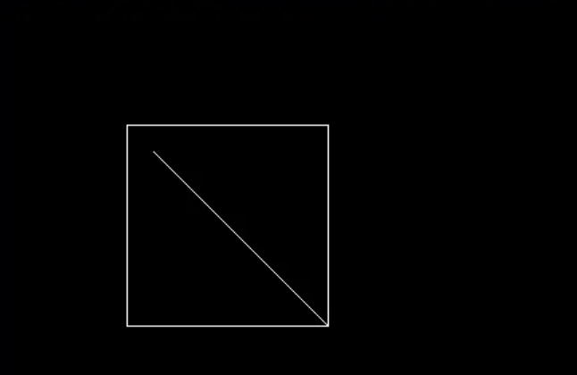

**Conclusion:**

The Liang Barsky algorithm is a computational method used for line clipping, which efficiently determines the intersections between a given line and a rectangular clipping window. It operates by calculating parameter values to define the points where the line enters and exits the window. This algorithm effectively reduces unnecessary calculations by utilizing the parametric representation of lines. By incorporating this approach, the Liang Barsky algorithm significantly enhances the efficiency of line clipping operations, making it a valuable tool for computer graphics and related applications.

**Experiment No. 8**

**Aim:** To implement Bezier curve for n control points. (Midpoint approach)

**Objective:**

Draw a Bezier curves and surfaces written in Bernstein basis form. The goal of interpolation

is to create a smooth curve that passes through an ordered group of points. When used in this

fashion, these points are called the control points.

**Theory:**

In midpoint approach Bezier curve can be constructed simply by taking the midpoints. In this

approach midpoints of the line connecting four control points (A, B, C, D) are determined

(AB, BC, CD, DA). These midpoints are connected by line segment and their midpoints are

ABC and BCD are determined. Finally, these midpoints are connected by line segments and

its midpoint ABCD is determined as shown in the figure –

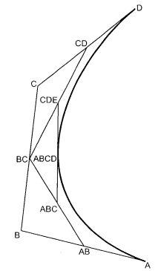

The point ABCD on the Bezier curve divides the original curve in two sections. The original curve gets divided in four different curves. This process can be repeated to split the curve into smaller sections until we have sections so short that they can be replaced by straight lines.

Algorithm:

1) Get four control points say A(xa, ya), B(xb, yb), C(xc, yc), D(xd, yd).

2) Divide the curve represented by points A, B, C, and D in two sections.

xab = (xa + xb) / 2

yab = (ya + yb) / 2

xbc = (xb + xc) / 2

ybc = (yb + yc) / 2

xcd = (xc + xd) / 2

ycd = (yc + yd) / 2

xabc = (xab + xbc) / 2

yabc = (yab + ybc) / 2

xbcd = ( xbc + xcd) / 2

ybcd = (ybc + ycd) / 2

xabcd = (xabc + xbcd) / 2

yabcd = (yabc + ybcd) / 2

3) Repeat the step 2 for section A, AB, ABC, ABCD and section ABCD, BCD, CD, D.

4) Repeat step 3 until we have sections so that they can be replaced by straight lines.

5) Repeat small sections by straight lines.

6) Stop.

**Program:**

#include<graphics.h>

#include<math.h>

#include<conio.h>

#include<stdio.h>

void main()

{

int x[4],y[4],i;

double put_x,put_y,t;

int gr=DETECT,gm;

initgraph(&gr,&gm,"C:\\TURBOC3\\BGI");

printf("\n****** Bezier Curve ***********");

printf("\n Please enter x and y coordinates ");

for(i=0;i<4;i++)

{

scanf("%d%d",&x[i],&y[i]);

putpixel(x[i],y[i],3);

}

for(t=0.0;t<=1.0;t=t+0.001)

{

put_x = pow(1-t,3)*x[0] + 3*t*pow(1-t,2)*x[1] + 3*t*t*(1-t)*x[2] + pow(t,3)*x[3]; // Formula to draw curve

put_y = pow(1-t,3)*y[0] + 3*t*pow(1-t,2)*y[1] + 3*t*t*(1-t)*y[2] + pow(t,3)*y[3];

putpixel(put_x,put_y, WHITE);

}

getch();

closegraph();

}

**Output:**

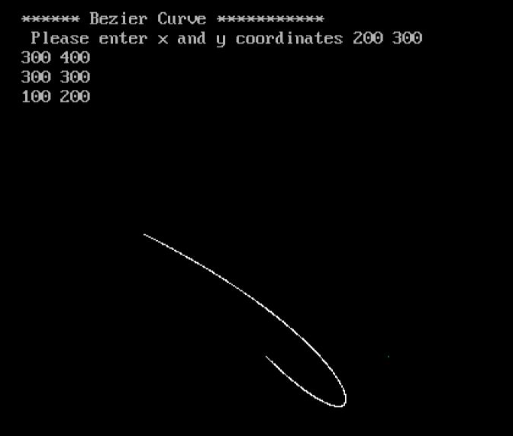

**Conclusion** – Comment on

1. Difference from arc and line

2. Importance of control point

3. Applications

Difference from arc and line:

Bezier curves differ from arcs and lines in their mathematical representation and the way they interpolate points. Unlike arcs that are defined by a radius and angle, and lines that have a constant slope, Bezier curves are defined by a set of control points that influence the shape of the curve. Bezier curves can produce more complex and flexible shapes than arcs and lines.

Importance of control points:

Control points are crucial in determining the shape and characteristics of a Bezier curve. They define the direction and extent of the curve segments, allowing for smooth and precise control over the curve's shape. By adjusting the positions and weights of control points, users can manipulate the curve's behavior and produce a wide variety of shapes, from simple curves to more complex and intricate designs.

Applications:

Bezier curves find extensive use in various fields, including computer graphics, animation, and industrial design. Some common applications include:

Computer Aided Design (CAD) software for creating and editing curves and surfaces.

Graphic design software for creating smooth and intricate shapes such as fonts, logos, and illustrations.

**Experiment No. 9**

**Aim:**  To implement Character Generation: Bit Map Method

**Objective:**

Identify the different Methods for Character Generation and generate the character using Stroke

**Theory:**

**Bit map method –**

Bitmap method is a called dot-matrix method as the name suggests this method use array of bits for generating a character. These dots are the points for array whose size is fixed.

• In bit matrix method when the dots are stored in the form of array the value 1 in array represent the characters i.e. where the dots appear we represent that position with numerical value 1 and the value where dots are not present is represented by 0 in array.

• It is also called dot matrix because in this method characters are represented by an array of dots in the matrix form. It is a two-dimensional array having columns and rows.

A 5x7 array is commonly used to represent characters. However, 7x9 and 9x13 arrays are also used. Higher resolution devices such as inkjet printer or laser printer may use character arrays that are over 100x100.

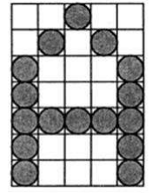

**Starburst method –**

In this method a fix pattern of line segments is used to generate characters. Out of these 24-line segments, segments required to display for particular character are highlighted. This method of character generation is called starburst method because of its characteristic appearance. The starburst patterns for characters A and M. the patterns for particular characters are stored in the form of 24 bit code, each bit representing one line segment. The bit is set to one to highlight the line segment; otherwise, it is set to zero. For example, 24-bit code for Character A is 0011 0000 0011 1100 1110 0001 and for character M is 0000 0011 0000 1100 1111 0011.

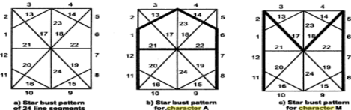

**Program:**

#include <stdio.h>

#include <conio.h>

#include <graphics.h>

int main()

{

int i,j,k,x,y;

int gd=DETECT,gm;//DETECT is macro defined in graphics.h

/* ch1 ch2 ch3 ch4 are character arrays that display alphabets */

int ch1[][10]={ {1,1,1,1,1,1,1,1,1,1},

{1,1,1,1,1,1,1,1,1,1},

{0,0,0,0,1,1,0,0,0,0},

{0,0,0,0,1,1,0,0,0,0},

{0,0,0,0,1,1,0,0,0,0},

{0,0,0,0,1,1,0,0,0,0},

{0,0,0,0,1,1,0,0,0,0},

{0,1,1,0,1,1,0,0,0,0},

{0,1,1,0,1,1,0,0,0,0},

{0,0,1,1,1,0,0,0,0,0}};

int ch2[][10]={ {0,0,0,1,1,1,1,0,0,0},

{0,0,1,1,1,1,1,1,0,0},

{1,1,0,0,0,0,0,0,1,1},

{1,1,0,0,0,0,0,0,1,1},

{1,1,0,0,0,0,0,0,1,1},

{1,1,0,0,0,0,0,0,1,1},

{1,1,0,0,0,0,0,0,1,1},

{1,1,0,0,0,0,0,0,1,1},

{0,0,1,1,1,1,1,1,0,0},

{0,0,0,1,1,1,1,0,0,0}};

int ch3[][10]={ {1,1,0,0,0,0,0,0,1,1},

{1,1,0,0,0,0,0,0,1,1},

{1,1,0,0,0,0,0,0,1,1},

{1,1,0,0,0,0,0,0,1,1},

{1,1,1,1,1,1,1,1,1,1},

{1,1,1,1,1,1,1,1,1,1},

{1,1,0,0,0,0,0,0,1,1},

{1,1,0,0,0,0,0,0,1,1},

{1,1,0,0,0,0,0,0,1,1},

{1,1,0,0,0,0,0,0,1,1}};

int ch4[][10]={ {1,1,0,0,0,0,0,0,1,1},

{1,1,1,1,0,0,0,0,1,1},

{1,1,0,1,1,0,0,0,1,1},

{1,1,0,1,1,0,0,0,1,1},

{1,1,0,0,1,1,0,0,1,1},

{1,1,0,0,1,1,0,0,1,1},

{1,1,0,0,0,1,1,0,1,1},

{1,1,0,0,0,1,1,0,1,1},

{1,1,0,0,0,0,1,1,1,1},

{1,1,0,0,0,0,0,0,1,1}};

initgraph(&gd,&gm,"C:\\TURBOC3\\BGI ");//initialize graphic mode

setbkcolor(LIGHTGRAY);//set color of background to darkgray

for(k=0;k<4;k++)

{

for(i=0;i<10;i++)

{

for(j=0;j<10;j++)

{

if(k==0)

{

if(ch1[i][j]==1)

putpixel(j+250,i+230,RED);

}

if(k==1)

{

if(ch2[i][j]==1)

putpixel(j+300,i+230,RED);

}

if(k==2)

{

if(ch3[i][j]==1)

putpixel(j+350,i+230,RED);

}

if(k==3)

{

if(ch4[i][j]==1)

putpixel(j+400,i+230,RED);

}

}

delay(200);

}

}

getch();

closegraph();

}

**Output –**

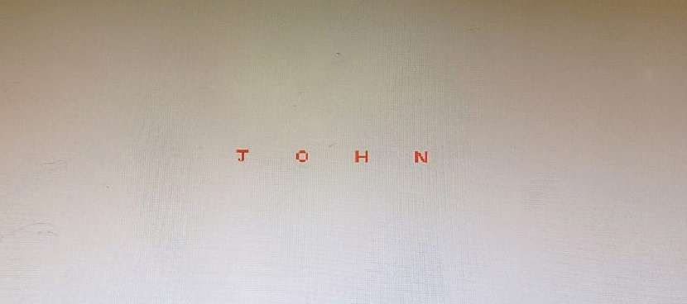

**Conclusion:**

Comment on

1. different methods
2. advantage of stroke method
3. one limitation

Different Methods: Bitmaps in computer graphics can be created using various methods, such as the grid-based pixel mapping, which involves assigning each pixel a specific color value, or the vector-based approach that uses mathematical equations to define shapes and lines. Both methods have their own applications and strengths, depending on the specific requirements of the graphics being created.

Advantage of Stroke Method: One of the key advantages of the stroke method in bitmap graphics is its ability to create smooth and precise lines, which is particularly useful for creating detailed and intricate designs.

One Limitation: Despite its advantages, one limitation of the stroke method in bitmap graphics is its tendency to consume a significant amount of memory and storage space, especially when dealing with complex and highly detailed images. This can pose challenges when working with large-scale projects or when there are constraints on available memory resources.

**Experiment No. 10**

**Aim:**  To develop programs for making animations such as

**Objective:**

Draw an object and apply various transformation techniques to this object. Translation, scaling and rotation is applied to object to perform animation.

**Theory:**

* For moving any object, we incrementally calculate the object coordinates and redraw the picture to give a feel of animation by using for loop.
* Suppose if we want to move a circle from left to right means, we have to shift the position of circle along x-direction continuously in regular intervals.
* The below programs illustrate the movement of objects by using for loop and also using transformations like rotation, translation etc.
* For windmill rotation, we use 2D rotation concept and formulas.

**Program:**

#include <stdio.h>

#include <graphics.h>

#include <dos.h>

int main() {

int gd = DETECT, gm;

int i, maxx, midy;

/* initialize graphic mode */

initgraph(&gd, &gm, "X:\\TC\\BGI");

/* maximum pixel in horizontal axis */

maxx = getmaxx();

/* mid pixel in vertical axis */

midy = getmaxy()/2;

for (i=0; i < maxx-150; i=i+5) {

/* clears screen */

cleardevice();

/* draw a white road */

setcolor(WHITE);

line(0, midy + 37, maxx, midy + 37);

/* Draw Car */

setcolor(YELLOW);

setfillstyle(SOLID_FILL, RED);

line(i, midy + 23, i, midy);

line(i, midy, 40 + i, midy - 20);

line(40 + i, midy - 20, 80 + i, midy - 20);

line(80 + i, midy - 20, 100 + i, midy);

line(100 + i, midy, 120 + i, midy);

line(120 + i, midy, 120 + i, midy + 23);

line(0 + i, midy + 23, 18 + i, midy + 23);

arc(30 + i, midy + 23, 0, 180, 12);

line(42 + i, midy + 23, 78 + i, midy + 23);

arc(90 + i, midy + 23, 0, 180, 12);

line(102 + i, midy + 23, 120 + i, midy + 23);

line(28 + i, midy, 43 + i, midy - 15);

line(43 + i, midy - 15, 57 + i, midy - 15);

line(57 + i, midy - 15, 57 + i, midy);

line(57 + i, midy, 28 + i, midy);

line(62 + i, midy - 15, 77 + i, midy - 15);

line(77 + i, midy - 15, 92 + i, midy);

line(92 + i, midy, 62 + i, midy);

line(62 + i, midy, 62 + i, midy - 15);

floodfill(5 + i, midy + 22, YELLOW);

setcolor(BLUE);

setfillstyle(SOLID_FILL, DARKGRAY);

/* Draw Wheels */

circle(30 + i, midy + 25, 9);

circle(90 + i, midy + 25, 9);

floodfill(30 + i, midy + 25, BLUE);

floodfill(90 + i, midy + 25, BLUE);

/* Add delay of 0.1 milli seconds */

delay(100);

}

closegraph();

return 0;

}

**Output:**

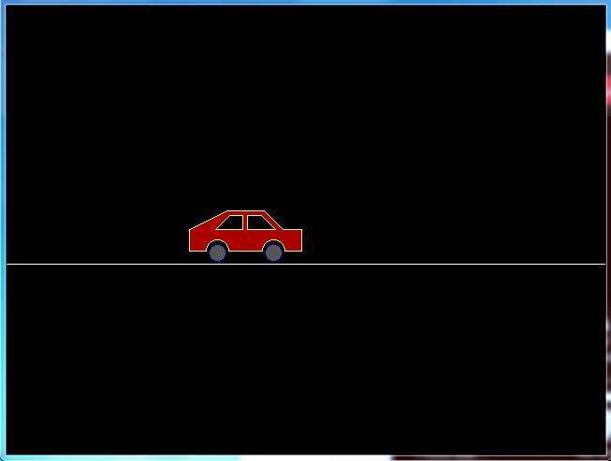

**Conclusion -** Comment on :

Conclusion:

1. Importance of Story Building:

The code provided is not directly related to storytelling, but it can be used as an analogy to highlight the importance of story building. In storytelling, just as in programming, having a well-structured and coherent narrative is crucial. Story building is the process of crafting a compelling and engaging plot that captures the audience's attention. Similarly, in coding, creating a well-organized and logical structure is essential for the successful execution of a program. Without a clear story or code structure, it becomes challenging to convey the intended message or achieve the desired outcome.

2. Defining the Basic Character of the Story:

In coding, defining the basic character of the story can be compared to setting up the initial parameters and variables that will drive the program. In the provided code, the basic character is the graphical representation of a car moving on a road. Similarly, in storytelling, the basic character represents the main protagonist, their characteristics, and the initial situation that sets the stage for the narrative. Without a well-defined character or program variables, the story or code may lack direction and purpose.

3. Applying Techniques to These Characters:

Just as storytelling involves applying various literary techniques to develop characters and advance the plot, programming requires the use of coding techniques to manipulate variables and achieve specific goals. In the code, techniques like drawing lines, filling shapes, and using delays are applied to create the animation of a moving car. Similarly, in storytelling, techniques such as foreshadowing, character development, and plot twists are used to engage the audience and convey the narrative effectively.

In summary, whether in coding or storytelling, the process of building a compelling story or program involves defining characters, establishing a structure, and applying techniques to engage the audience or achieve the desired outcome. Both domains benefit from a thoughtful and well-organized approach to create a meaningful and impactful experience.

Experiment No. 10 Mini Project